European Committee on Crime Problems
(CDPC)

PC-CP (2025)9
English

SPACE I - 2025

"COUNCIL OF EUROPE ANNUAL PENAL STATISTICS
- SURVEY ON THE POPULATION OF PENAL INSTITUTIONS"

Your country

SPACE I – SURVEY 2025

Conducted on behalf of the Council of Europe by

Prof. Marcelo F. Aebi (PhD) & Edoardo Cocco (MLaw)

University of Lausanne

PC-CP Website: www.coe.int/prison SPACE Website: www.unil.ch/space

Council of Europe Annual Penal Statistics SPACE I: Scope & Guidelines

Scope of the Council of Europe Annual Penal Statistics SPACE I: Population of Penal Institutions
● | These statistics encompass the entire population of inmates under the responsibility of the Prison Administration.
● | The data collected refers to all types of penal institutions, including:
 | ○ | Institutions for inmates not serving a final sentence (pre-trial detainees), institutions for inmates serving custodial sanctions and measures (sentenced inmates), and institutions for juvenile offenders (minors).
 | ○ | Diverse institutional settings such as closed, semi-open, or open facilities, which might include semi-custodial institutions or work farms.
● | SPACE I does NOT refer to persons serving non-custodial sanctions and measures in the community (probationers) who are under the responsibility of probation agencies. Such data are collected through the SPACE II questionnaire. If you cannot avoid including that data in your answers, please state it in the comments. That would help us avoid double counting when comparing both questionnaires.
Purpose of the SPACE I questionnaire
● | This questionnaire seeks to consistently gather and compare data from all member states of the Council of Europe.
● | To enhance the accuracy of the comparisons, the questionnaire incorporates questions regarding the specifics of certain categories and the way in which the data are collected for the statistics (metadata).
● | The questionnaire also proposes definitions as well as some rules of inclusion and exclusion. National correspondents answering the questionnaire are kindly requested to align their national categories to those proposed by SPACE I to facilitate comprehensive European-level comparisons. Whenever that is not feasible, they are asked to indicate the discrepancies in the comments.
● | Any additional insights about the nuances of each national legal system will be highly appreciated and can also be indicated in the relevant comments’ sections.
Instructions for Completing the SPACE I questionnaire
● | Please ensure clarity in your responses. For each item, choose only one of the following answers:
 | NAP | Not applicable. Choose this if the question is irrelevant because the notion it refers to does not exist in your criminal justice system.
 | NA | Not available. Choose this if you do not have the figures, but the item exists in your criminal justice system.
 | 0 | Zero. Choose this if the number is zero at the reference date and the item exists in your criminal justice system.
 | # | A specific number (other than 0): Use this to indicate the actual number as of the reference date.
● | Avoid using symbols like “–”, “/”, “---” or similar.
● | Ensure that no item remains unanswered.
● | Answers left blank will be interpreted as referring to an item that is not available (NA)
● | The distinction between not available (NA) and not applicable (NAP) is paramount to understand the figures in the questionnaire. Please do not forget to indicate each the item that is not applicable because it does not exist in your criminal justice system
Abbreviations used in the SPACE I questionnaire
● | The following abbreviations are used throughout the SPACE I questionnaire:
 | PA | Prison Administration (plural: PAs).
 | e.g. | (exempli gratia): For example.
 | i.e. | (id est): That is to say. Used to introduce a phrase that restates or clarifies the previous statement.
Deadline
● | Kindly submit the filled-out questionnaire by 10 November 2025. Send it to the following addresses:
 | Edoardo.Cocco@unil.ch (copy to Marcelo.Aebi@unil.ch)
Contact us
● | If you have any question concerning the questionnaire, please contact
 | Mr. Edoardo Cocco (Edoardo.Cocco@unil.ch), tel. +41 21 692 46 43
 | Prof. Marcelo F. Aebi (Marcelo.Aebi@unil.ch), tel. +41 21 692 46 43

Section One: Indicators of stock on 31st January 2025

Structure of Section One

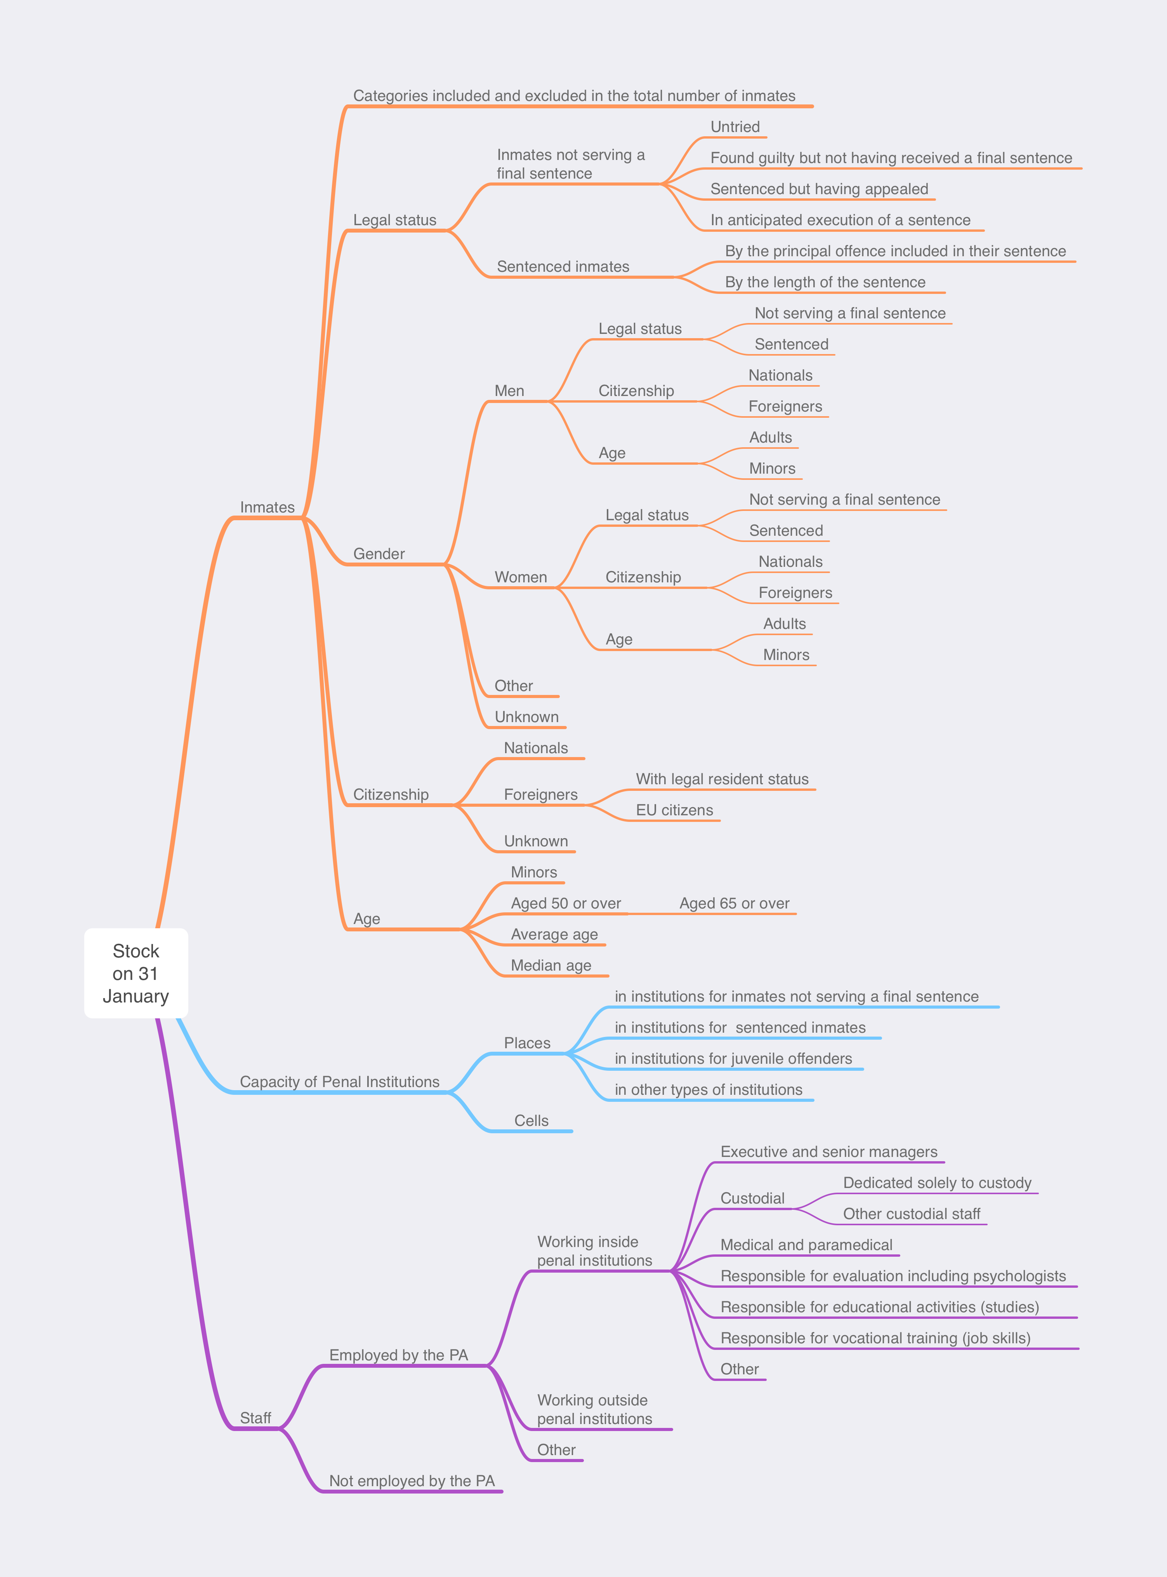

Instructions for completing Section One and related questions

General remarks
● | Stock indicators refer to the situation on 31 January 2025. If you use any other date of reference, please state it in the comments
● | The main stock indicators refer to the number and characteristics of inmates, capacity of penal institutions and staff of the prison administration.
● | We urge National Correspondents to align your data with the following definitions and instructions as closely as possible. When this requires adjusting the figures published by your prison administration, please indicate the adjustments in the comments.
● | If, for any reason, such adjustments are unfeasible or if your prison administration restricts you from making them, kindly answer NO the relevant question below and detail the discrepancies in the comments.
General instructions
● | Ensure that figures provided do not include double counting.
● | For all items, if the information is not available, please indicate NA.
● | For all items, if the information required refers to a notion that does not exist in your country, please indicate NAP (not applicable).
● | Please provide clarifications or explanations in the comments.

Definitions

1 | Penal institutions
 | All facilities used for the confinement of persons arrested for, charged with, convicted of, or sentenced for an offence, including closed, semi-closed and open institutions
2 | Inmates
 | All persons confined in penal institutions (i.e., persons arrested for, charged with, convicted of, or sentenced for an offence, and placed in a penal institution)
 | Of which
 | 2.1. | Inmates not serving a final sentence
 |  | This self-defining category is often referred to as “pre-trial detainees”, “detainees on remand”, “non-sentenced detainees”, or “remand inmates”
 |  | Of which
 |  | 2.1.1 |  | Inmates untried
 |  |  |  | Inmates for whom a judicial decision has not been reached yet
 |  | 2.1.2 |  | Inmates found guilty but without a final sentence
 |  |  |  | In some countries (e.g., the UK) a defendant is first declared guilty (or not guilty) by a magistrate, jury, or judge and, in a second time, the judge passes a sentence
 |  | 2.1.3 |  | Inmates sentenced pending appeal
 |  |  |  | Refers to persons who received a sentence but have appealed or who are within the statutory limit to do so
 |  | 2.1.4 |  | Inmates in anticipated execution of a sanction
 |  |  |  | In some countries (e.g., Switzerland) a defendant can, under specific circumstances, request to start serving a custodial sanction before receiving a final sentence (and hence have access to the regime foreseen for sentenced inmates, which is less strict than that for pre-trial detainees)
 | 2.1. | Sentenced inmates
3 | Sentenced inmates by the principal offence included in their sentence
 | Under the principal offence rule, only the most severe crime is considered in instances where an individual is sentenced for multiple offences. Typically, the severity of an offence is judged by the maximum penalty defined by law.
 | Q1-1 | Does your country apply the principal offence rule? |  |  |  |  |  |  |  | ? YES or NO ?
 | Q1-2 | If NO, does your country apply the count-all-offences rule (i.e., all offences that an individual has been sentenced for are counted, without prioritising their severity). If your answer is NO, please explain the rule applied in the comments |  |  |  |  |  |  |  | ? YES or NO ?
4 | Age
 | 4.1. | Average age of the prison population
 |  | Correspond to the sum of the ages of all inmates divided by the total number of inmates.
 | 4.2. | Median age of the prison population
 |  | The median is the value that divides the data in two equal groups so that 50% of the inmates are above the median and 50% are below it. To calculate the median, first sort inmates by age in ascending order. The median age is the age of the inmate located in the middle of this list. If there is an even number of inmates, the median is the average of the two middle ages.
 | 4.3. | Age and criminal responsibility
Table A below presents the information currently available for all Council of Europe member states regarding their ages of (a) criminal responsibility, (b) minimal age for the application of custodial sanctions and measures, and (c) criminal majority.
If the information reported in the table is inaccurate, please correct it in the comments.
5 | Citizenship
 | 5.1. | Nationals and foreigners
 |  | National inmates are those with the citizenship of the country in which they are detained, while foreigners are those who do not have that citizenship
 | 5.2. | Foreigners with a permanent resident status
 |  | These are non-citizens lawfully authorized to reside permanently in the country.
 | Q1-3 | Does your “foreigners with a permanent resident status” definition align with the above? If NO, please provide your definition in the comments |  |  |  |  |  |  |  | ? YES or NO ?
6 | Capacity of penal institutions
 | The capacity of penal institutions refers to the number of inmates that can be accommodated inside them. It is typically expressed as the number of places, knowing that each place represents the space required to accommodate one inmate respecting the criteria set out in the European Prison Rules. A basic distinction is made between design capacity and operational capacity.
 | ● | Design capacity refers to the number of inmates that a penal institution was originally designed to accommodate. It is typically based on the architect's intended number of occupants.
 | ● | Operational capacity is a flexible metric subject to change over time and considers additional factors beyond the prison's original design. These factors can include shifts in policy regarding the acceptable number of inmates per cell, modifications to the prison's physical structure, or temporary measures like the use of extra beds in cells or communal spaces.
 | The total capacity of penal institutions reported in the questionnaire should correspond to the number of places originally intended for the facilities (design capacity)
 | Q1-4 | Does your “total capacity of penal institutions” definition align with the above? If NO, please provide your definition in the comments |  |  |  |  |  |  |  | ? YES or NO ?
 | Prison administrations apply specific rules for estimating the space required for an inmate. Table B below presents the rules applied in the member states that provided such information when answering previous SPACE reports. If the information reported in the table is inaccurate, please correct it in the comments
 | The questionnaire also asks for the total number of cells available in penal institutions
 | Q1-5 | Does the capacity of penal institutions allow inmates to be accommodated during the night in individual cells? |  |  |  |  |  |  |  | ? YES or NO ?
7 | Staff
 | Include:
 | ● | All personnel involved in the appropriate functioning of the prison administration
 | ● | Include both full-time and part-time staff. For part-time personnel, use “Ful Time Equivalents (FTE)”. Examples: Two employees, each working 50% of the regular hours, are viewed as one FTE; an employee at 50% regular hours corresponds to 0.5 FTE.
 | ● | Includes persons employed by the prison administration (a) working inside penal institutions and (b) working outside penal institutions (e.g., the General Headquarters of some PAs are placed in premises situated outside any penal institution)
 | Exclude:
 | ● | Some countries have private prisons with independent staff. Typically, PAs will not count the persons working in these prisons as part of their staff. However, if that is the case for your PA, you can indicate their number in Table 3.
 | ● | There are PAs that outsource some services to private entities (e.g., transportation of inmates, security at the entrance of penal institutions, or cleaning services). Typically, PAs will not count the persons working in these entities as part of their staff. However, if that is the case for your PA, you can indicate their number in Table 3.
 | ● | Probation staff (i.e., staff belonging to the probation agencies that are responsible for the supervision of community sanctions and measures). This staff should be counted in the SPACE II questionnaire. However, some countries only have one entity responsible both for inmates and probationers. If that is the case four your PA and these persons are included in your total staff, please indicate their in the relevant in Table 3.
 | Q1-5 | Does your “staff” definition align with the above? |  |  |  |  |  |  |  | ? YES or NO ?
 | Q1-6 | Does your “total number of staff” include the following categories
 |  | 6.1 | Staff employed by the prison administration working inside penal institutions |  |  |  |  |  |  | ? YES or NO ?
 |  | 6.2 | Staff employed by the prison administration working outside penal institutions |  |  |  |  |  |  | ? YES or NO ?
 |  | 6.3 | Staff not employed by the prison administration working in private prisons |  |  |  |  |  |  | ? YES/NO/NAP ?
 |  | 6.4 | Staff not employed by the prison administration working in private entities that deliver services outsourced by the prison administration |  |  |  |  |  |  | ? YES/NO/NAP ?
 |  |  | 6.4.1 |  | If YES, which are the services outsourced by your prison administration?
 |  | 6.4 | Staff working in probation agencies (in charge of probationers serving community sanctions and measures) |  |  |  |  |  |  | ? YES/NO/NAP ?

Table A (Metadata): Age and criminal responsibility

The Table below presents the information currently available on the ages of (a) criminal responsibility, (b) minimal age for the application of custodial sanctions and measures, and (c) criminal majority by country. If the information reported in the table is incorrect, please correct it in the comments.

Country | Age of criminal responsibility | Minimal age for the application of custodial sanctions and measures | Age of criminal majority
Albania | 14 | 14 | 18
Andorra | 12 | 12 | 12
Armenia | 14/16 | 16 | 18
Austria | 14 | 14 | 18
Azerbaijan | 14 | 14 | 18
Belgium | 16/18 | 16/18 | 18
BH: BiH (total)
BH: BiH (st. level)
BH: Fed. BiH
BH: Rep. Srpska | 14 | 14 | 18
Bulgaria | 14 | 14 | 18
Croatia | 14 | 14 | 18
Cyprus | 14 | 14 | 16
Czech Rep. | 15 | 15 | 18
Denmark | 15 | 15 | 18
Estonia | 14 | 14 | 18
Finland | 15 | 15 | 18
France | 13 | 16 | 18
Georgia | 15 | 15 | 18
Germany | 14 | 14 | 18
Greece | 15 | 15 | 18
Hungary | 14 | 14 | 18
Iceland | 15 | 15 | 18
Ireland | 12 | 12 | 18
Italy | 14 | 14 | 18
Latvia | 14 | 14 | 18
Liechtenstein | 14 | 14 | 18
Lithuania | 14 | 14 | 18
Luxembourg | 16 | 16 | 18
Malta | 14 | 14 | 18
Moldova | 14 | 14 | 18
Monaco | 13 | 13 | 18
Montenegro | 14 | 16 | 18
Netherlands | 12 | 12 | 18
North Macedonia | 14 | 16 | 18
Norway | 15 | 15 | 18
Poland | 13 | 15 | 17
Portugal | 16 | 16 | 21
Romania | 14 | 14 | 18
San Marino | 14 | 14 | 18
Serbia (Republic of) | 14 | 14 | 18
Slovak Rep. | 14 | 14 | 18
Slovenia | 14 | 16 | 18/21
Spain (total) | 14 | 14 | 18
Spain (State Adm.) | 14 | 14 | 18
Spain (Catalonia) | 14 | 14 | 18
Sweden | 15 | 15 | 21
Switzerland | 10 | 15 | 18
Türkiye | 12 | 12 | 18
Ukraine | 14 | 16 | 18
UK: Engl. & Wales | 10 | 15 | 18
UK: North. Ireland | 10 | 10 | 18
UK: Scotland | 12 | 16 | 21

Table B (Metadata): Capacity in places - calculation of the space per inmate

The Table below presents the information currently available on how the space per inmate is calculated in several prison administrations. If the information reported in the table is incorrect, please correct it in the comments. If your prison administration is not included in the Table and you have the relevant information, please report it also in the comments.

Country
Denmark | Capacity calculated from 4 sqm/inmate
Georgia | The capacity of penal institutions in Georgia covers cells that can be occupied by one inmate or by multiple inmates (2 to 4 inmates).
Italy | In Italy, the current regular capacity of penal establishments is calculated on the basis of a Decree of the Ministry of Health of 1975 relevant to civil houses; the parameters of said Ministerial Decree were wholly adopted by the Penitentiary Administration: in particular, the surface foreseen for a single room is 9 square metres, plus 5 square metres for each further bed in multiple occupancy rooms.
Netherlands | Prison capacity represents the operational capacity of the adult prison system.
Romania | The capacity of penitentiary institutions is calculated at 4 square meters, according to the Order of the Minister of Justice No. 2772/2017.The capacity of penitentiary hospitals is calculated at 7 square metres, and it is not considered as a capacity of penitentiary (accommodation) institutions, being intended only for the hospitalization of prisoners.
Slovakia | General remark about the capacity: The total accommodation capacity is calculated according to legally determined accommodation area: 3.5 m² for accused/sentenced man; 4 m² for accused/sentenced juvenile and accused/sentenced woman. The exceptions are the Remand Prison and Prison Bratislava and the Prison Dubnica nad Váhom, where the accommodation capacity in reconstructed areas is determined on 4 m² for one accused/sentenced person.  The accommodation area of a cell or a room is determined from the total area of the cell/room after deduction of the area occupied by the sanitary facility placed in the cell/room, the separated toilet placed in the cell/room, the area over which is the clear height of the cell/room less than 1 300 mm, the area covered with built-in furniture, and the area for windows and doors. The accommodation area of the cell/room includes the area of the bow window and recess, if they are at the same time at least 1 200 mm wide, 300 mm deep and 2 000 mm high from the floor.  In prison facilities it is possible to place an inmate separately either when the capacities are currently created in the particular prison or the prison governor decides so, in order to protect the safety of the inmate or other persons or for other serious reason. It follows that rooms or cells are not built with regard to separate accommodation.
Spain | Capacity means the places available in residential modules.  Residential module cells are designed to house two inmates.  Although there are enough places to meet the demand of any person who wants to be alone in a cell, not the entire prison population is located individually due to reasons such as: the geographical distribution of the prisons, the transitory execution of refurbishment works and improvement, the willingness to share people's cells, etc.
Sweden | It is not possible to exclude the capacity for inmates in remand prisons who are detained for other reasons than suspicion of crime, for example inmates taken in custody awaiting deportation. Therefore, the capacity for these inmates is included in the capacity for inmates not serving a final sentence (pre-trial detainees).
Switzerland | In the Custody Survey, it is not possible to differentiate between single cells and other cells. In principle, sentenced persons should have access to an individual cell. In reality, this is not guaranteed in all institutions of deprivation of liberty and is adapted to the needs. For those who have not yet been sentenced, the provision of a single cell is not guaranteed.
Türkiye | There are single and multiple cells and according to security issues inmates could stay in single cells. Nevertheless, in juvenile institutions, there are single cells which children could accommodate during the night for sleeping.
Ukraine | According to paragraph 36 of section VI of the Instruction on the Procedure for Conducting a Technical Inventory of Real Estate Objects, approved by order of the State Committee for Construction, Architecture and Housing Policy of Ukraine dated May 24, 2001 No. 127, as amended by order of the Ministry of Regional Development, Construction and Housing and Communal Services of Ukraine dated 26 July 2018 No. 186, when calculating the area of objects, the area in houses for keeping convicts of block, barracks and cell types for convicts is determined as the sum of the areas of all the main functional premises.  In accordance with paragraph 38 of section VI of the instructions, the living area of the cells in houses for the detention of convicts and persons taken into custody is determined by the dimensions measured between the finished surfaces of walls and partitions at a level of 1.10-1.30 m from the floor, without taking into account the area of the sanitary.  The information is provided in accordance with the order of the Department for the Execution of Criminal Punishments dated April 13, 2020 No. 80 / OD-20 “On Establishing the Filling of Institutions for the Execution of Punishments and Pre-trial Detention Centers”
UK: England and Wales | Useable Operational Capacity: This is the sum of all establishments’ operational capacity less 2,000 places. This is known as the operating margin and reflects the constraints imposed by the need to provide separate accommodation for different classes of prisoner, i.e. by sex, age, security category, conviction status, single cell risk assessment and also due to geographical distribution.

Table C (Metadata): Categories included in the total number of inmates

Instructions:
* Item 1 - Persons held in police stations or other similar types of investigative institutions before trial: refers to persons held in institutions other than the regular prison facilities. In particular, these include police stations, centres for temporary detention in order to put the person at the disposal of the judicial authorities (e.g. izolâtor vremennogo soderžaniâ [UKR], investigative detention facilities [BGR], cells kept by the border guards), or any other similar institution. Please fill in item 1.1.1 only if these persons are included in your total prison population (item 1.0).
** Item 7 - Persons under security measures/private detention for dangerous offenders: concerns inmates detained under special measures. These prisoners are usually defined as “dangerous offenders”. The measures may take different names such as security measure, secure prevention detention or preventive supervision. According to the Recommendation CM/Rec(2014) 3¹ (Strasbourg, 19 February 2014): a dangerous offender is a person who has been convicted of a very serious sexual or very serious violent crime against persons and who presents a high likelihood of re-offending with further very serious sexual or very serious violent crimes against persons.

C.1. Does the total number of inmates include the following categories? |  |  | - YES  - NO  - NAP: Not applicable | If YES, how many?
1. | Persons held in police stations or other similar types of investigative institutions before trial*
2. | Persons held in custodial institutions/units for juvenile offenders
3. | Persons placed in educational institutions/units for juvenile offenders
4. | Persons held in institutions for drug-addicted offenders outside penal institutions
5. | Persons with psychiatric disorders held in psychiatric institutions or hospitals outside penal institutions
6. | Asylum seekers or illegal aliens held for administrative reasons
7. | Persons under security measures/private detention for dangerous offenders**
 | Of which:
 | 7.1 | Persons held as not criminally responsible by the court
 | 7.2 | Persons held as totally or partially criminally responsible by the court and who have been sentenced
8. | Persons held in public-private partnership prisons
9. | Persons held in private prisons
10. | Persons held in other private facilities
11. | Persons under electronic monitoring (please specify in the comments below the type of surveillance applied; e.g. electronic bracelet, and whether they are counted in the SPACE II questionnaire)
12. | Persons serving other community sanctions and measures and counted in the SPACE II questionnaire (if yes, please specify why in the comments below)

C.2. Are young children permitted to reside with their incarcerated mothers in penal institutions? |  | YES/NO ?
If YES: | 1. How many children are living with their mothers inside penal institutions?
If YES: | 2. Age Limit for Cohabitation: Specify the maximum age at which children are allowed to stay with their mothers inside penal institutions.

Comments to Definitions and Tables on Metadata (A, B & C)

Table 1.1 Indicators of stock on 31st January 2025: Inmates (Part 1 of 2)
1.1. Characteristics of inmates on 31st January 2025 (Part 1 of 2)
 |  |  |  |  |  |  | Numbers
1 | Number of inmates (total)
 | Of which: Inmates by legal status
 |  | 1.1 | Inmates not serving a final sentence
 |  |  | Of which: Detainees
 |  |  | 1.1.1 | untried
 |  |  | 1.1.2 | found guilty but without a final sentence
 |  |  | 1.1.3 | sentenced pending appeal
 |  |  | 1.1.4 | in anticipated execution of a sanction
 |  |  | 1.1.5 | unknown/other
 |  | 1.2 | Sentenced inmates
 |  | 1.3 | Unknown
 | Of which: Inmates by gender
 |  | 1.4 | Men
 |  | 1.5 | Women
 |  | 1.6 | Other
 |  | 1.7 | Unknown
 | Of which: Inmates by citizenship
 |  | 1.8 | Nationals
 |  |  | Of which: By legal status
 |  |  | 1.8.1 | not serving a final sentence
 |  |  | 1.8.2 | sentenced
 |  | 1.9 | Foreigners
 |  |  | Of which (a): By resident status in the country
 |  |  |  | 1.9.1 | with legal resident status
 |  |  | Of which (B): By EU citizenship
 |  |  |  | 1.9.2 | citizens of an EU country
 |  |  | Of which (B): By legal status
 |  |  |  | 1.9.3 | not serving a final sentence
 |  |  |  | 1.9.4 | sentenced
 |  | 1.10 | Unknown
 | Of which: Inmates by age
 |  | 1.11 | Adults
 |  |  | Of which: Aged
 |  |  | 1.11.1 | 18 to 25 years
 |  |  | 1.11.2 | 26 to 49 years
 |  |  | 1.11.3 | 50 to 64 years
 |  |  | 1.11.4 | 65 years and over
 |  |  | 1.11.5 | Unknown
 |  | 1.12 | Minors
 |  | 1.13 | Average age of the prison population
 |  | 1.14 | Median age of the prison population

Table 1.2 Indicators of stock on 31st January 2025: Inmates (Part 2 of 2)
1.2. Characteristics of inmates on 31st January 2025 (Part 2 of 2)

 | Category | Not serving a final sentence* |  | Foreigners |  | Minors |  | Total inmates
Gender
Men |  | A |  | B |  | C |  | (=1.4)
Women |  | D |  | E |  | F |  | (=1.5)
Other |  | G |  | H |  | I |  | (=1.6)
Unknown |  | J |  | K |  | L |  | (=1.7)
Total inmates |  | (=1.1) |  | (=1.9) |  | (=1.12) |  | (=1)

Table 1.3 Indicators of stock on 31st January 2025: Sentenced inmates
1.3. Characteristics of sentenced inmates on 31st January 2025
 |  |  |  |  | Numbers
1.2 | Sentenced inmates (=1.2)
 | Of which: By principal offence included in their sentence
 |  | 1.2.1 | Homicide (including attempts)
 |  | 1.2.2 | Assault and battery
 |  | 1.2.3 | Rape
 |  | 1.2.4 | Other types of sexual offences
 |  | 1.2.5 | Robbery
 |  | 1.2.6 | Theft
 |  | 1.2.7 | Economic / financial offences
 |  | 1.2.8 | Drug offences
 |  | 1.2.9 | Terrorism
 |  | 1.2.10 | Road traffic offences
 |  | 1.2.11 | Other offences
 |  | 1.2.12 | Total (=1.2)
 | Of which: By length of the sentence imposed
 |  | 1.2.13 | Less than 1 month
 |  | 1.2.14 | From 1 month to less than 3 months
 |  | 1.2.15 | From 3 months to less than 6 months
 |  | 1.2.16 | Form 6 months to less than 1 year
 |  | 1.2.17 | From 1 year to less than 3 years
 |  | 1.2.18 | From 3 years to less than 5 years
 |  | 1.2.19 | From 5 years to less than 10 years
 |  | 1.2.20 | From 10 years to less than 20 years
 |  | 1.2.21 | 20 years and over
 |  | 1.2.22 | Life imprisonment
 |  | 1.2.23 | Security measures
 |  | 1.2.24 | Death sentence
 |  | 1.2.25 | Other
 |  | 1.2.26 | Total (=1.2)

Table 2. Indicators of stock on 31st January 2025: Penal institutions
2. Penal institutions
 |  |  |  |  | Numbers
2 | Capacity of penal institutions
 | 2.1 | Number of places (total)
 |  | Of which: in
 |  | 2.1.1 | institutions for inmates not serving a final sentence
 |  | 2.1.2 | institutions for sentenced inmates
 |  | 2.1.3 | institutions for juvenile offenders (minors)
 |  | 2.1.4 | other types of institutions
 | 2.2 | Number of cells (total)

Table 3. Indicators of stock on 31st January 2025: Staff
3. Staff
 |  |  |  |  |  |  |  |  | Numbers
3 | Staff: Total in Full Time Equivalents (FTE)
 | Of which
 | 3.1 | Staff employed by the Prison Administration (PA)
 |  | Of which: Staff working
 |  | 3.1.1 | inside penal institutions
 |  |  | Of which:
 |  |  | 3.1.1.1 | Executive and senior managers
 |  |  | 3.1.1.2 | Custodial staff
 |  |  |  | Of which:
 |  |  |  | 3.1.1.2.1 | Dedicated solely to custody
 |  |  |  | 3.1.1.2.2 | Other custodial staff
 |  |  | 3.1.1.3 | Medical and paramedical
 |  |  | 3.1.1.4 | Responsible for evaluation including psychologists
 |  |  | 3.1.1.5 | Responsible for educational activities (studies)
 |  |  | 3.1.1.6 | Responsible for vocational activities (job skills)
 |  |  | 3.1.1.7 | Other staff
 |  | 3.1.2 | outside penal institutions
 |  | 3.1.3 | other
 | 3.2 | Staff not employed by the Prison Administration (PA)
 |  | Of which: Staff
 |  | 3.2.1 | working in private prisons
 |  | 3.2.2 | working in private entities that deliver services outsourced by the prison administration
 |  | 3.2.3 | in charge of probationers serving community sanctions and measures (probation staff)

Comments to Section One, Tables 1 to 3

Section Two: Indicators of flow for the year 2024

Structure of Section Two

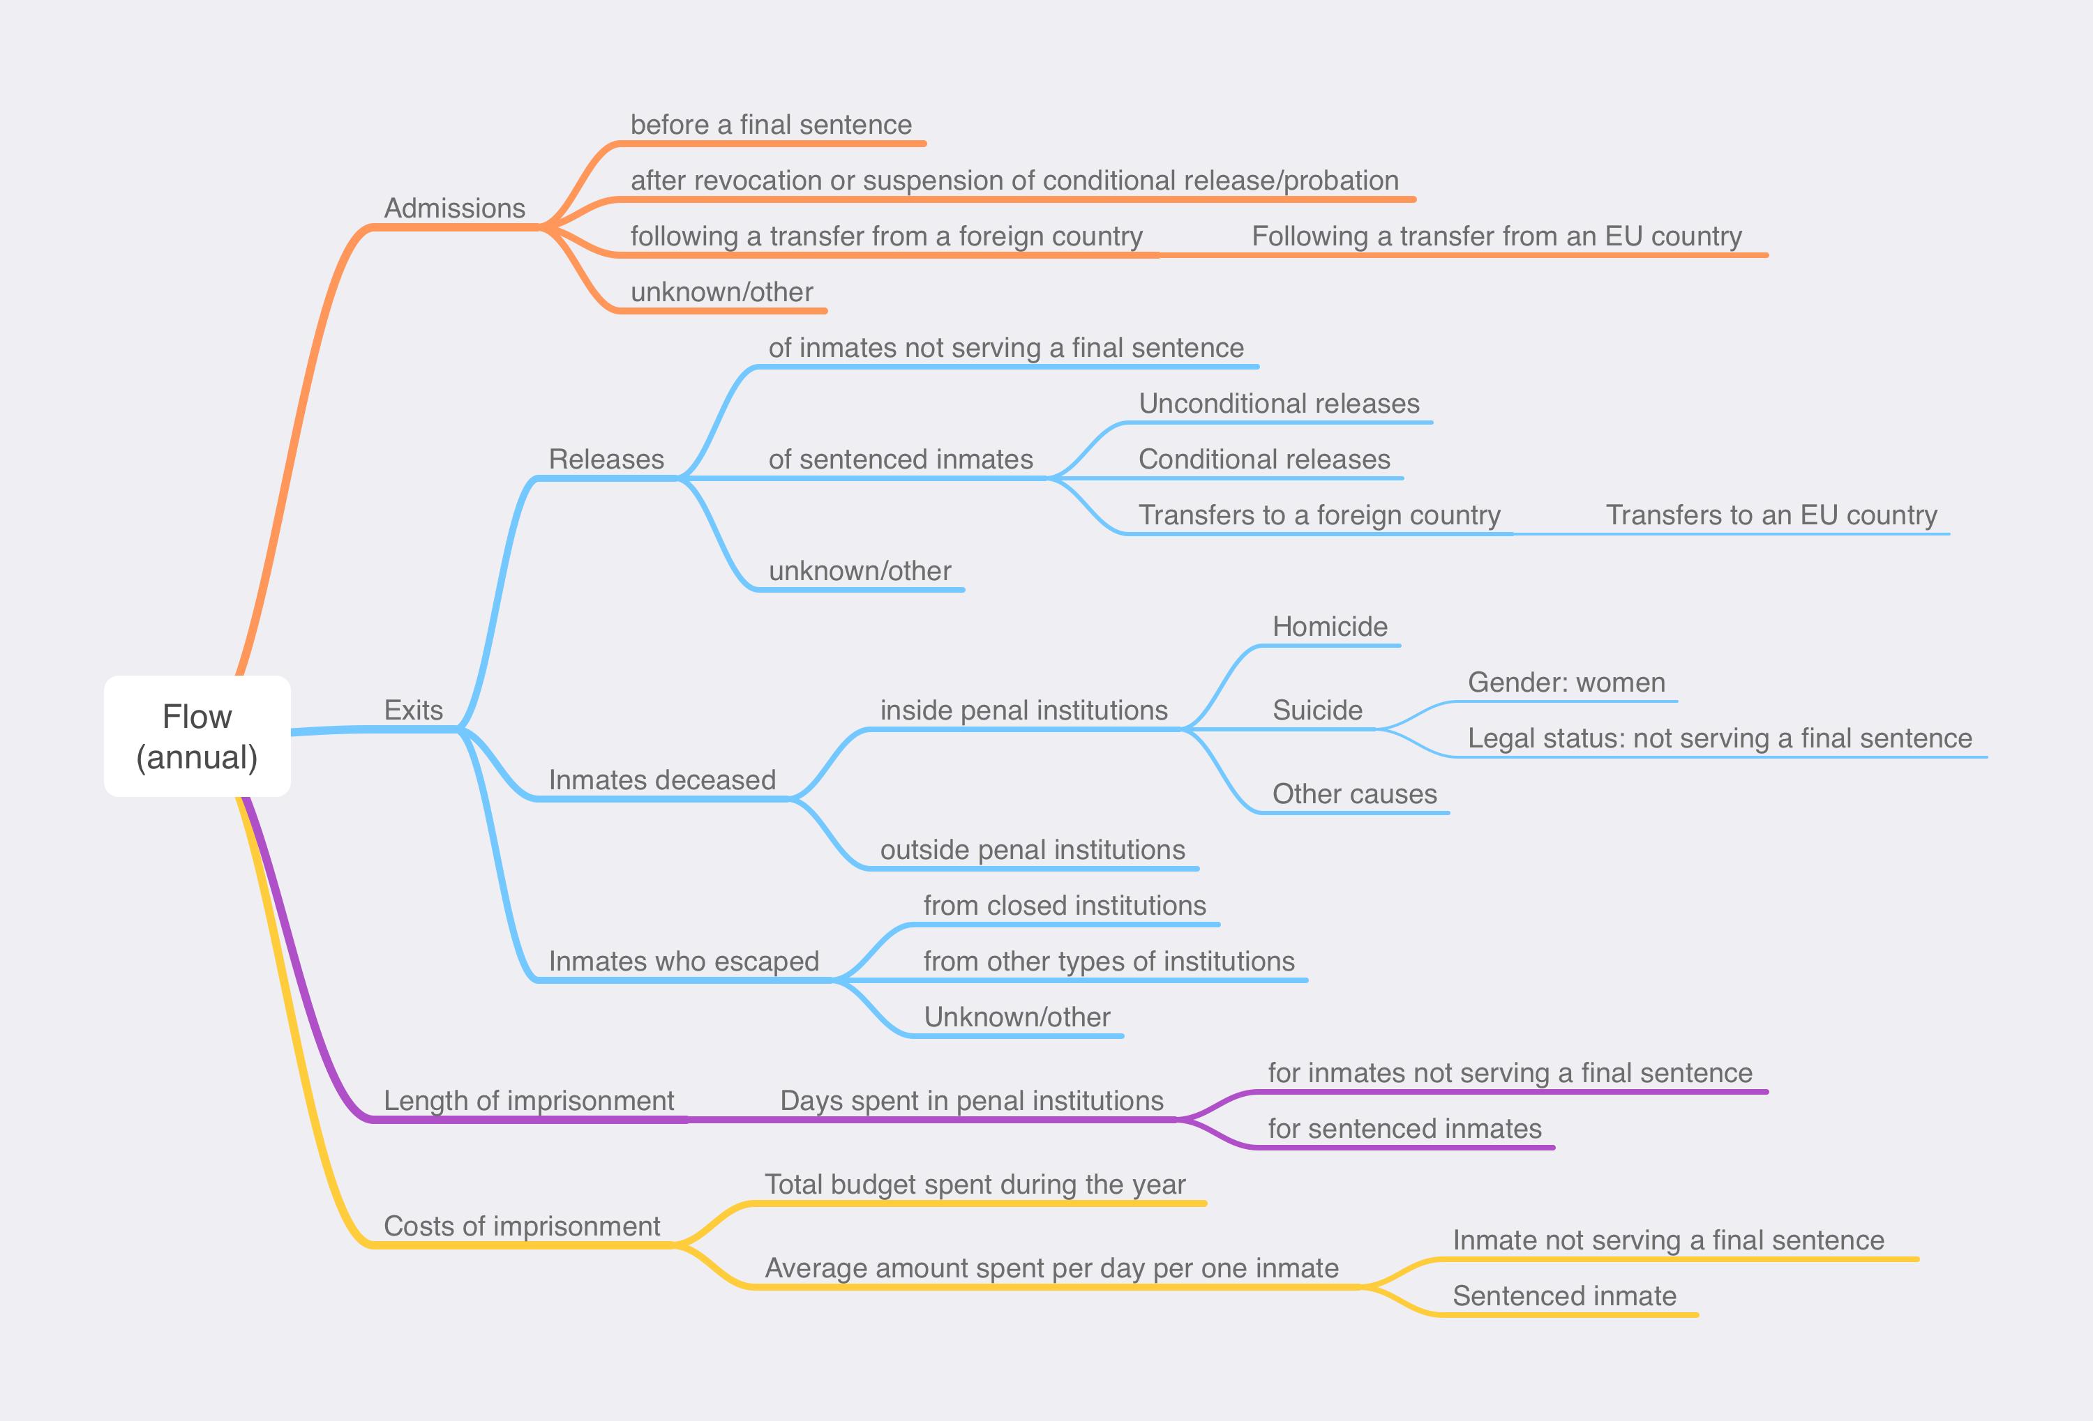

Instructions for completing Section Two and related questions

General remarks
Flow indicators refer to the movements and changes in the prison population over a full year and help understand the dynamics of that population, for example the management of prison capacities. Its main indicators are the admissions and exits from penal institutions, the length of imprisonment and the costs of imprisonment during the year or reference.
One of the primary objectives of SPACE is to assure the uniformity and comparability of indicators gathered from various prison administrations. To achieve this:
- The instructions provided herein are derived from a thorough examination of previous SPACE reports. They encapsulate the predominant practices adopted by most prison administrations when compiling their statistics.
- For National Correspondents in countries with differing practices: We urge you to align your data with these guidelines as closely as possible. When this requires adjusting the figures published by your prison administration, please annotate them in the comments box at the end of this section.
- If, for any reason, such adjustments are unfeasible or if your prison administration restricts you from making them, kindly answer NO the relevant question below and detail the discrepancies in the comments box at the end of this section.
By diligently following these guidelines, we can collectively ensure that the data collected is both comprehensive and comparable, enhancing the quality and utility of the SPACE project.

General Instructions
- Reference Date: Ensure all data are for the entire year 2024.
- Ensure that figures provided do not include double counting (e.g., inmates moving between institutions).
- For all items, if the information is not available, please indicate NA.
- For all items, if the information required refers to a notion that does not exist in your country, please indicate NAP (not applicable)
- Please provide clarifications or explanations in the comments section of the table.

Detailed definitions and instructions

1. Admissions
- Counting unit: The admission into any penal institution (the same person can be admitted more than once during the year).
- Rules of inclusion/exclusion
- Included:
  - Admissions of inmates not serving a final sentence (pre-trial detainees).
  - Admissions of persons who have been found guilty but not yet sentenced.
  - Admissions of persons who have been sentenced and have lodged an appeal or are within the statutory time limit to do so.
- Excluded:
  - Admissions following transfers between institutions.
  - Admission following temporary removals for judicial appearances.
  - Admission following temporary removals for hospital treatments.
  - Returns after prison leaves.
  - Returns after escape and subsequent re-incarceration.
- Questions
 | Q2-1.1 | Does your "admissions" definition align with the above? |  | ? YES or NO ?
 | Q2.1.2 | Do you count suspects in police cells if they remain at least one day? |  | ? YES or NO ?
 |  | Q2.1.2.2 | If YES, how many were admitted in 2024?

2. Releases
- Counting unit: The release from any penal institution (the same person can be released more than once during the year).
- Rules of inclusion/exclusion
- Included:
  - Releases of inmates belonging to any of the categories included in the “admissions” section above.
  - Releases with and without conditions (conditional and unconditional releases)
  - Transfers to another country.
- Excluded:
  - Transfers between local penal institutions.
  - Temporary removals for judicial appearances.
  - Temporary removals for hospital treatments.
  - Placements in other types of penal institutions.
 | Q2-2.1 | Does your "releases" definition align with the above? | ? YES or NO ?

3. Deceased Inmates
- Counting unit: The person (the inmate who died).
- Explanation: Some prison administrations count only the inmates who died inside penal institutions, while others include those who died outside, often under some conditions that can vary from country to country. To ensure comparability in the SPACE report, data for these distinct categories are requested separately. Cause of death is requested only for inmates who died inside penal institutions.
 | Q2-3.1 | Does your "deceased inmates" definition align with the above? | ? YES or NO ?

4. Inmates who escaped from penal institutions
- Counting unit: The person (the inmate who escaped, also known as escapee).
- Explanation: Each escapee is counted individually, even in a collective breakout (the same person could escape more than once during the year).
 | Q2-4.1 | Does your "escapee" definition align with the above? |  | ? YES or NO ?
 | Q2.4.2 | Do you count inmates who arrived late from a prison leave as escapees? |  | ? YES or NO ?
 |  | Q2.4.2.2 | If YES, how many are included in the figures provide for escapees in 2024?

5. Length of Imprisonment
- Counting unit: Total number of days spent in penal institutions.
- Explanation: This figure is typically calculated by administrative services tasked with determining the costs of imprisonment.
- Rules of inclusion/exclusion
  - Included:
    - Days spent in custody by all persons who were admitted in penal institutions at least one day during the year.
    - Detention periods awaiting a court decision and time spent serving sentences.
    - All categories of persons deprived of freedom included in Part One of this questionnaire.
 | Q2-5.1 | Does your "length of imprisonment" definition align with the above? |  | ? YES or NO ?
 | Q2.5.2 | Do you count days spent in police cells if the suspect remains at least one day? |  | ? YES or NO ?
 |  | Q2.5.2.2 | If YES, how many days were spent in police cells in 2024?

6. Costs of Imprisonment
- Counting unit: Euro
- Total budget spent during the year:
  - Reflects the total budget spent by the prison administration during the year.
  - May not align with the initial budget set at the year's start.
  - Should encompass all prison system expenses, including services outsourced to private entities.
  - Please specify if the budget includes the functioning of the country's probation agencies.
- Rules of inclusion/exclusion
  - Included:
    - Security.
    - Healthcare.
    - Services.
    - Administration.
    - Support.
    - Rehabilitation programs.
    - Amounts paid to private entities for outsourced services.
 | Q2-5.1 | Does your "total budget spent by the prison administration" definition align with the above? |  | ? YES or NO ?
 | Q2.5.2 | Does your budget include expenses related to the functioning of probation agencies? |  | ? YES or NO ?
 |  | Q2.5.2.2 | If YES, what was the budget spent for the functioning of probation agencies in 2024?

Table 4. Indicators of flow for the year 2024
4. Admissions exits, length and costs of imprisonment during the entire year 2024
Numbers
1 | Admissions into penal institutions (total)
 | Of which: Admissions
 | 1.1 | before a final sentence
 | 1.2 | after revocation or suspension of a conditional release or probation
 | 1.3 | following a transfer from a foreign country
 |  | Of which 1.3.1 | Following a transfer from an EU country
 | 1.4 | after a final sentence
 | 1.5 | unknown/other
 | Note: 1.1 + 1.2 + 1.3 +1.4 + 1.5 = 1 (if not, please explain why in the comments)
2 | Releases from penal institutions (total)
 | Of which: Releases
 | 2.1 | of inmates not serving a final sentence
 | 2.2 | of sentenced inmates
 |  | Of which:
 |  | 2.1.1 | Unconditional releases
 |  | 2.1.2 | Conditional releases
 |  | 2.1.3 | Transfers to another country
 |  |  | Of which: 2.1.3.1 | Transfers to an EU country
 | 2.3 | unknown/other
 | Note: 2.1 + 2.2 + 2.3 = 2 (if not, please explain why in the comments)
3 | Inmates deceased (total)
 | Of which: Inmates deceased
 | 3.1 | inside penal institutions
 |  | Of which: Inmates deceased by
 |  | 3.1.1 | Homicide
 |  | 3.1.2 | Suicide
 |  |  | Of which (a): By gender
 |  |  |  | 3.1.2.1 | Women inmates
 |  |  | Of which (B): By legal status
 |  |  |  | 3.1.2.2 | Inmates not serving a final sentence
 |  | 3.1.3 | Other causes of death
 | 3.2 | outside penal institutions
Note: 3.1 + 3.2 = 3 and 3.1.1 + 3.1.2 + 3.1.3 = 3.1 (if not, please explain why in the comments)
4 | Inmates who escaped from penal institutions (total)
 | Of which: Inmates who escaped from
 | 4.1 | closed penal institutions
 | 4.2 | other types of penal institutions
 | 4.3 | unknown/other
Note: 4.1 + 4.2 + 4.3 = 4 (if not, please explain why in the comments)
 |  |  | Days
5 | Total number of days spent penal institutions (total)
 | Of which: Days spent in
 | 5.1 | institutions for inmates not serving a final sentence
 | 5.2 | institutions for sentenced inmates
 |  | Euro
6 | Costs of imprisonment
 | 6.1 | Total budget spent during the year
 | 6.2 | Average amount spent per day per one inmate
 |  | Of which: Amount spent per day per one
 |  | 6.2.1 | inmate not serving a final sentence
 |  | 6.2.2 | sentenced inmate

Comments to Section Two

Table 7. Measures having an influence on prison populations
Reference date: from the 1 February 2024 to the 31 January 2025

Instructions
Please indicate legislative measures or any other kind of measures (e.g. indults pronounced by the Executive Power) applied from the 1 February 2024 to the 31 January 2025 which had a direct influence on trends in the number of prisoners (amnesty, collective pardon, etc.): If you have data on the influence of such measures on the prison population, please provide them also (e.g. Pardon pronounced on 1st May leading to the release of 300 prisoners).

a) | Changes in criminal law (please be specific: provide a short explanatory note)
b) | New legislation concerning certain categories of inmates
 |  | Explanatory note | Number of persons concerned by the measures
c) | Amnesties
d) | Individual pardons
e) | Collective pardons
f) | Other (specify)

Comments to Table 7

Please give the name and address of the person responsible for completing this questionnaire, so that we may contact him/her for clarification of the answers if necessary.

Name:
Function:
Institution:
Address:
Telephone:
E-mail:

Thank you very much!

